**Exercise 1: Control Structures**

**Implementation:**

**CODE:**

**=> To create table & insert data:**

CREATE TABLE customers (

customer_id NUMBER PRIMARY KEY,

name VARCHAR2(100),

age NUMBER,

balance NUMBER,

IsVIP VARCHAR2(5) DEFAULT 'FALSE'

);

CREATE TABLE loans (

loan_id NUMBER PRIMARY KEY,

customer_id NUMBER,

interest_rate NUMBER,

due_date DATE,

FOREIGN KEY (customer_id) REFERENCES customers(customer_id)

);

INSERT INTO customers VALUES (1, 'Alice', 65, 15000, 'FALSE');

INSERT INTO customers VALUES (2, 'Bob', 45, 8000, 'FALSE');

INSERT INTO customers VALUES (3, 'Charlie', 70, 5000, 'FALSE');

INSERT INTO customers VALUES (4, 'Diana', 35, 12000, 'FALSE');

INSERT INTO loans VALUES (101, 1, 5.5, SYSDATE + 10);

INSERT INTO loans VALUES (102, 2, 6.0, SYSDATE + 40);

INSERT INTO loans VALUES (103, 3, 7.0, SYSDATE + 20);

INSERT INTO loans VALUES (104, 4, 4.5, SYSDATE + 5);

COMMIT;

=> **To view table:**

SELECT * FROM customers;

SELECT * FROM loans;

=> **Scenario 1: To apply discount for customers above 60 years old:**

BEGIN

FOR rec IN (SELECT * FROM customers) LOOP

IF rec.age > 60 THEN

UPDATE loans

SET interest_rate = interest_rate - 1

WHERE customer_id = rec.customer_id;

DBMS_OUTPUT.PUT_LINE('Applied 1% discount for ' || rec.name);

END IF;

END LOOP;

END;

=> **Scenario 2: To promote to VIPS for customers with balance over 10000:**

BEGIN

FOR rec IN (SELECT * FROM customers) LOOP

IF rec.balance > 10000 THEN

UPDATE customers

SET IsVIP = 'TRUE'

WHERE customer_id = rec.customer_id;

DBMS_OUTPUT.PUT_LINE('Promoted ' || rec.name || ' to VIP!');

END IF;

END LOOP;

END;

=> **Scenario 3: To send remainders to customers whose loan due is within next 30 days :**

BEGIN

FOR rec IN (

SELECT c.name, l.due_date

FROM loans l

JOIN customers c ON l.customer_id = c.customer_id

WHERE l.due_date BETWEEN SYSDATE AND SYSDATE + 30

) LOOP

DBMS_OUTPUT.PUT_LINE('Reminder: Dear ' || rec.name || ', your loan is due on ' || TO_CHAR(rec.due_date, 'DD-MON-YYYY'));

END LOOP;

END;

**OUTPUT:**

**Table:**

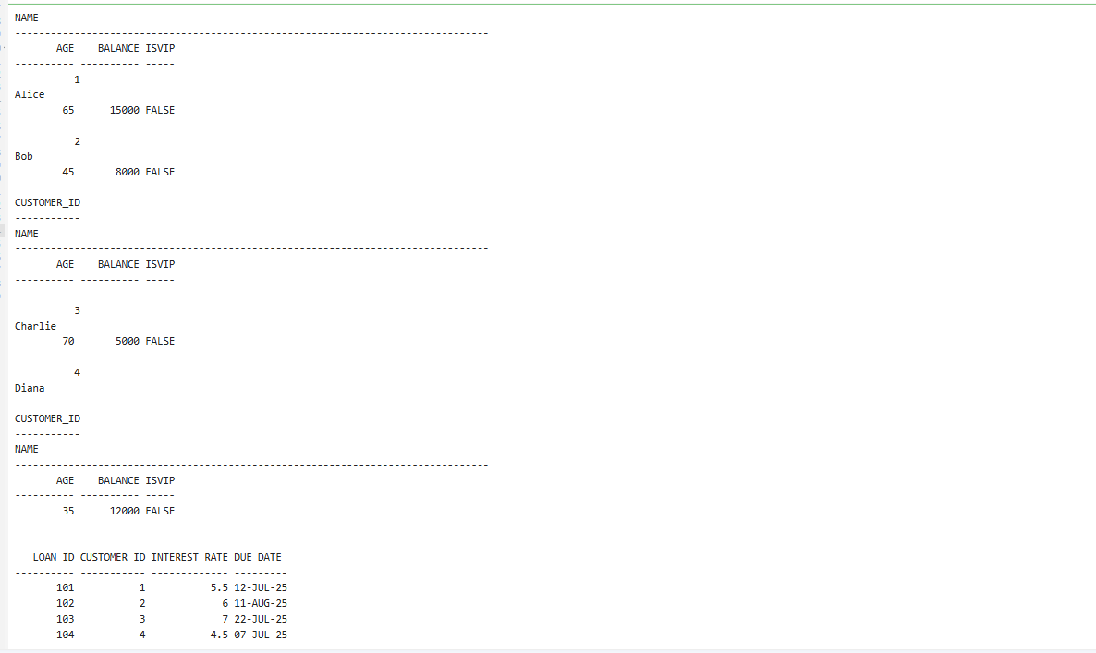

**Scenario 1:**

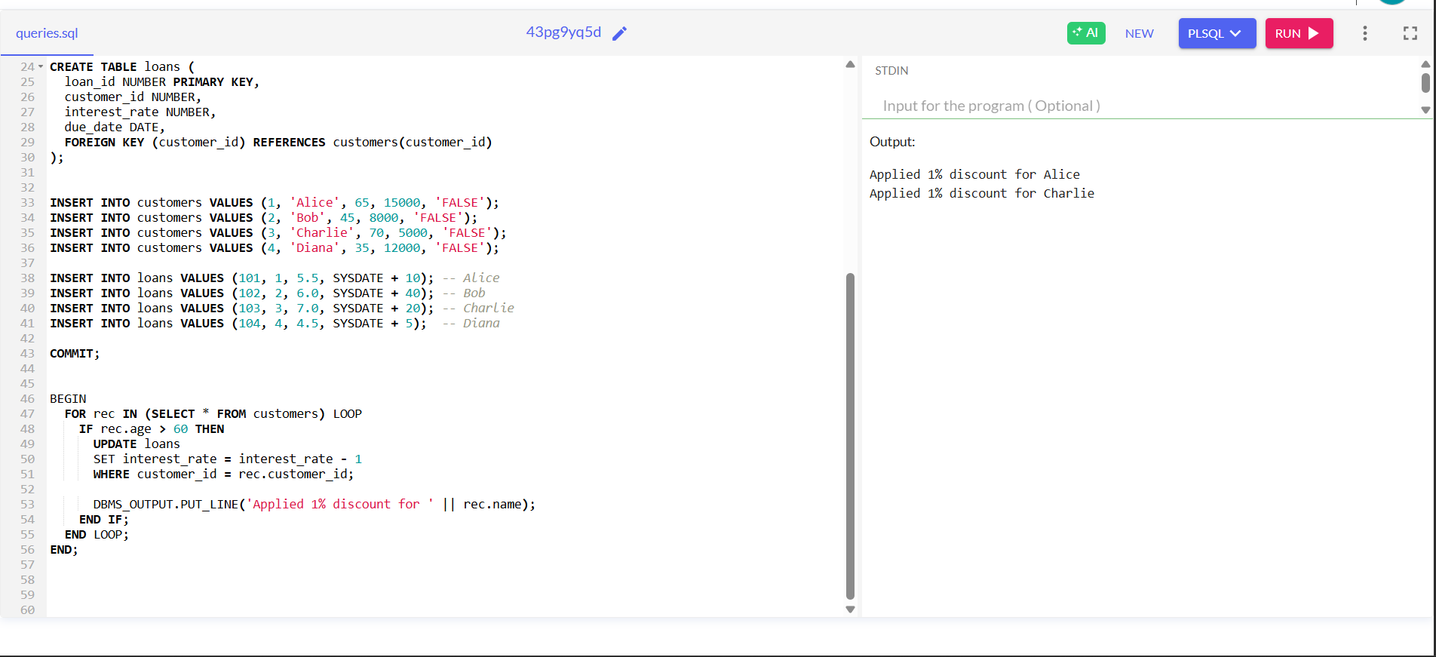

**Scenario 2:**

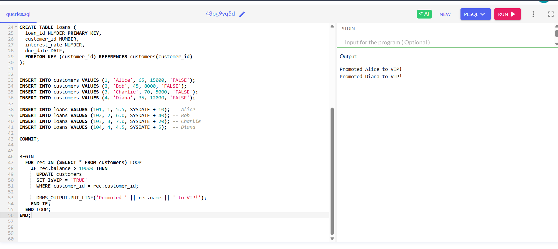

**Scenario 3:**

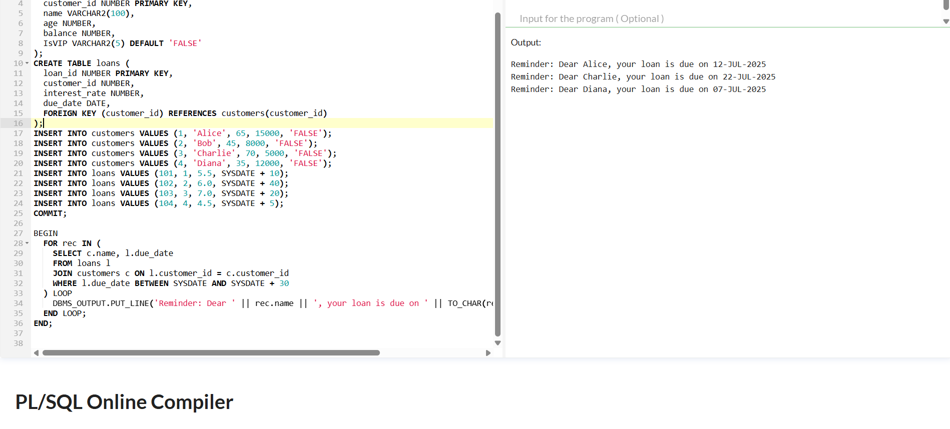

**Exercise 3: Stored Procedures**

**Implementation:**

**CODE:**

**=> To create table and insert data:**

CREATE TABLE accounts (

account_id NUMBER PRIMARY KEY,

customer_id NUMBER,

balance NUMBER,

account_type VARCHAR2(20)

);

CREATE TABLE employees (

emp_id NUMBER PRIMARY KEY,

name VARCHAR2(100),

department_id NUMBER,

salary NUMBER

);

INSERT INTO accounts VALUES (1001, 1, 5000, 'SAVINGS');

INSERT INTO accounts VALUES (1002, 1, 3000, 'CHECKING');

INSERT INTO accounts VALUES (1003, 2, 8000, 'SAVINGS');

INSERT INTO accounts VALUES (1004, 2, 2000, 'SAVINGS');

INSERT INTO employees VALUES (1, 'Alice', 101, 5000);

INSERT INTO employees VALUES (2, 'Bob', 101, 5500);

INSERT INTO employees VALUES (3, 'Charlie', 102, 6000);

COMMIT;

=> **To view table:**

select * from accounts;

select * from employees;

=> **Scenario 1: ProcessMonthlyInterest**

CREATE OR REPLACE PROCEDURE ProcessMonthlyInterest IS

BEGIN

UPDATE accounts

SET balance = balance * 1.01

WHERE account_type = 'SAVINGS';

COMMIT;

END;

/

BEGIN

DBMS_OUTPUT.PUT_LINE('Before Interest:');

FOR r IN (SELECT * FROM accounts WHERE account_type = 'SAVINGS') LOOP

DBMS_OUTPUT.PUT_LINE('Account ' || r.account_id || ': ' || r.balance);

END LOOP;

ProcessMonthlyInterest;

DBMS_OUTPUT.PUT_LINE('After Interest:');

FOR r IN (SELECT * FROM accounts WHERE account_type = 'SAVINGS') LOOP

DBMS_OUTPUT.PUT_LINE('Account ' || r.account_id || ': ' || r.balance);

END LOOP;

END;

/

=> **Scenario 2: UpdateEmployeeBonus**

CREATE OR REPLACE PROCEDURE UpdateEmployeeBonus (

p_dept_id IN NUMBER,

p_bonus_pct IN NUMBER

) IS

BEGIN

UPDATE employees

SET salary = salary + (salary * p_bonus_pct / 100)

WHERE department_id = p_dept_id;

COMMIT;

END;

/

BEGIN

DBMS_OUTPUT.PUT_LINE('Before Bonus:');

FOR r IN (SELECT * FROM employees WHERE department_id = 101) LOOP

DBMS_OUTPUT.PUT_LINE(r.name || ': ' || r.salary);

END LOOP;

UpdateEmployeeBonus(101, 10);

DBMS_OUTPUT.PUT_LINE('After Bonus:');

FOR r IN (SELECT * FROM employees WHERE department_id = 101) LOOP

DBMS_OUTPUT.PUT_LINE(r.name || ': ' || r.salary);

END LOOP;

END;

/

=> **Scenario 3: TransferFunds**

CREATE OR REPLACE PROCEDURE TransferFunds (

p_from_account IN NUMBER,

p_to_account IN NUMBER,

p_amount IN NUMBER

) IS

v_balance NUMBER;

BEGIN

SELECT balance INTO v_balance

FROM accounts

WHERE account_id = p_from_account

FOR UPDATE;

IF v_balance < p_amount THEN

RAISE_APPLICATION_ERROR(-20001, 'Insufficient funds in source account.');

END IF;

UPDATE accounts

SET balance = balance - p_amount

WHERE account_id = p_from_account;

UPDATE accounts

SET balance = balance + p_amount

WHERE account_id = p_to_account;

COMMIT;

END;

/

BEGIN

DBMS_OUTPUT.PUT_LINE('Before Transfer:');

FOR r IN (SELECT * FROM accounts WHERE account_id IN (1001, 1002)) LOOP

DBMS_OUTPUT.PUT_LINE('Account ' || r.account_id || ': ' || r.balance);

END LOOP;

-- Call procedure

TransferFunds(1001, 1002, 1000); -- Transfer $1000 from 1001 to 1002

DBMS_OUTPUT.PUT_LINE('After Transfer:');

FOR r IN (SELECT * FROM accounts WHERE account_id IN (1001, 1002)) LOOP

DBMS_OUTPUT.PUT_LINE('Account ' || r.account_id || ': ' || r.balance);

END LOOP;

END;

/

**OUTPUT:**

**=> Table:**

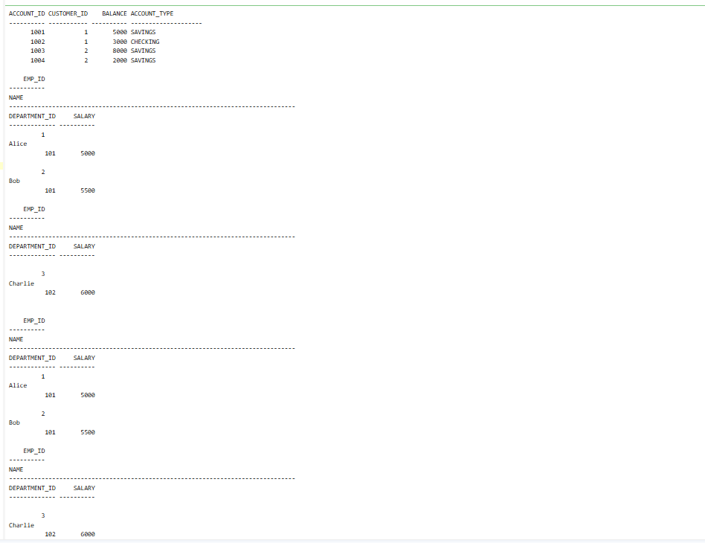

**Scenario 1:**

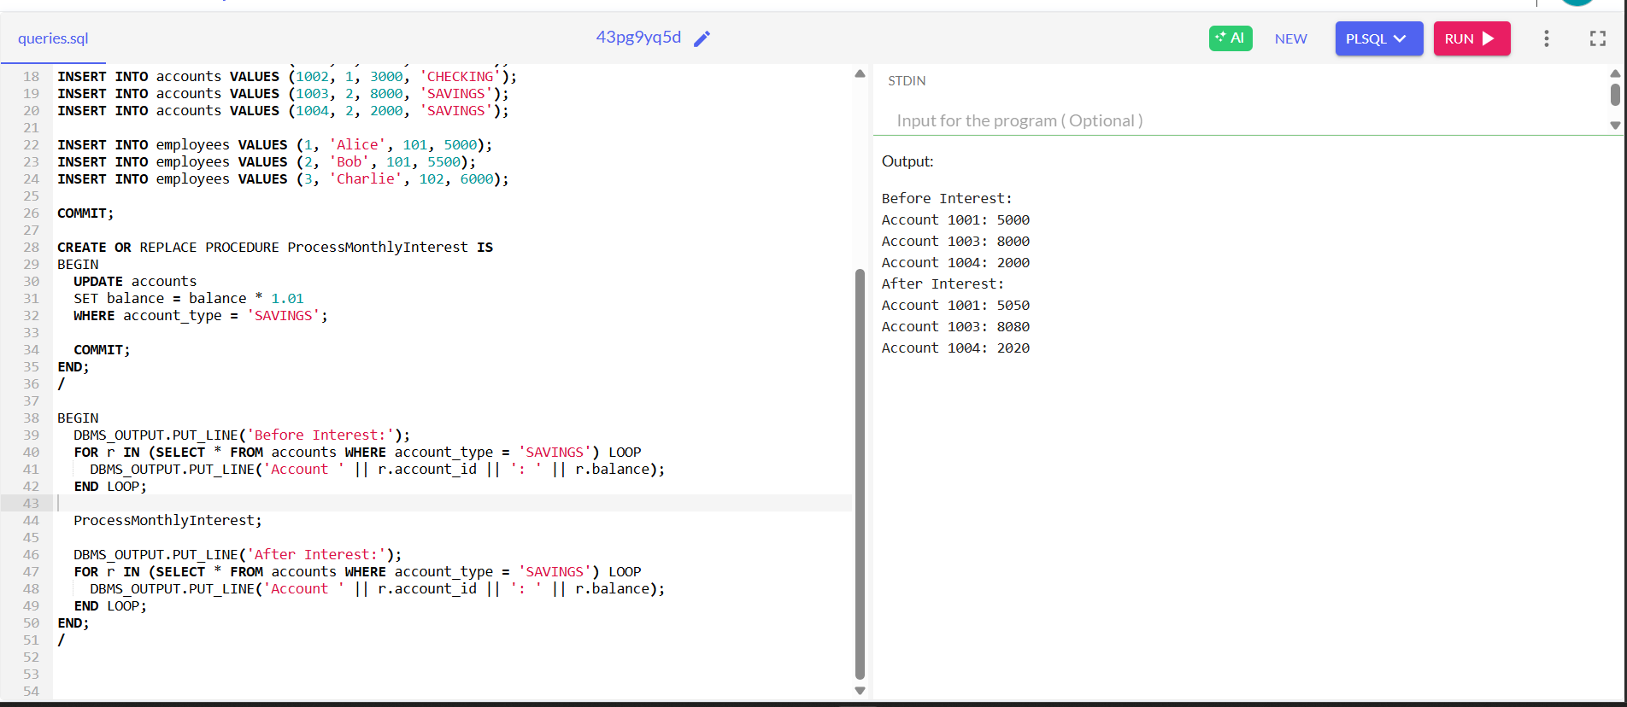

**Scenario 2:**

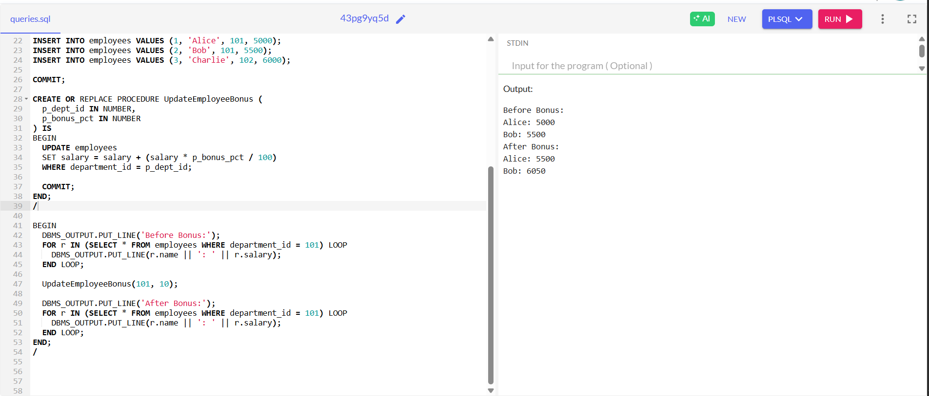

**Scenario 3:**

